Description

Intended User

Features

User Interface Mocks

Screen 1

Screen 2

Key Considerations

How will your app handle data persistence?

Describe any corner cases in the UX.

Describe any libraries you’ll be using and share your reasoning for including them.

Describe how you will implement Google Play Services.

Next Steps: Required Tasks

Task 1: Project Setup

Task 2: Implement UI for Each Activity and Fragment

Task 3: Your Next Task

Task 4: Your Next Task

Task 5: Your Next Task

**GitHub Username**: Your GitHub username here

Storyteller

# Description

The goal of this app is to connect people across the globe who like to read or write stories. Some of the different genres will be presented and users can choose in which one their story belongs, or what kind of story they want to read.

Users will be able to save their favorite authors and stories and access them anytime.

# Intended User

Everyone is a storyteller. App is mainly for people who like to write or improve their writing skills, but it’s also for those who like reading.

# Features

List the main features of your app:

* Creates user accounts
* Stores all of the stories in the database
* Allows users to read and write stories
* Stores favorites in local database making them accessible at all time

# User Interface Mocks

## Screen 1

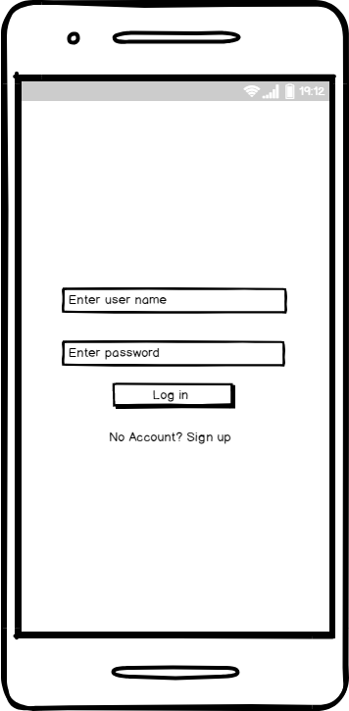

Provide descriptive text for each screen

## Screen 2

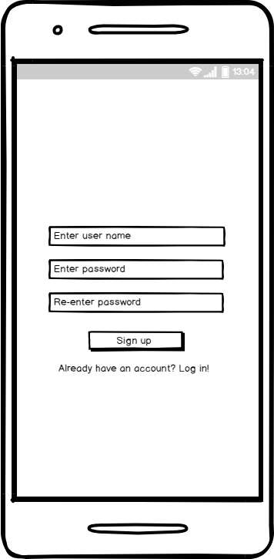

Provide descriptive text for each screen

## Screen 2



Provide descriptive text for each screen

## Screen 2



Provide descriptive text for each screen

## Screen 2



Provide descriptive text for each screen

## Screen 2



Provide descriptive text for each screen

## Screen 2



Provide descriptive text for each screen

## Screen 2



Provide descriptive text for each screen

# Key Considerations

### How will your app handle data persistence?

Data will be stored using Firebase Realtime Database. SQLite database will be used only for favorites.

### Describe any edge or corner cases in the UX.

Fragment will be popped from stack on back navigation.

### Describe any libraries you’ll be using and share your reasoning for including them.

Gson – will be used to convert Java objects into their JSON representation, and the other way around.

### Describe how you will implement Google Play Services or other external services.

Firebase Authentication – used to create user accounts. Users will be able to sign up using their email and password. This is so they can log in on any device, and it is necessary to create a user account since we’re using the database.

Firebase Realtime Database – used to store/retrieve data about users and stories.

# Next Steps: Required Tasks

This is the section where you can take the main features of your app (declared above) and break them down into tangible technical tasks that you can complete one at a time until you have a finished app.

## Task 1: Project Setup

* Create project in Android Studio
* Create theme for project
* Configure styles, dimensions, colors and strings
* Create a folder structure
* Add dependencies
* Configure libraries

## Task 2: Implement UI for Each Activity and Fragment

* Build UI for Splash Screen
* Build UI for Login and Signup screens
* Build UI for

## Task 3: Your Next Task

Describe the next task. For example, “Implement Google Play Services,” or “Handle Error Cases,” or “Create Build Variant.”

Describe the next task. List the subtasks. For example:

* Create layout
* Something else

## Task 4: Your Next Task

Describe the next task. List the subtasks. For example:

* Create layout
* Something else

## Task 5: Your Next Task

Describe the next task. List the subtasks. For example:

* Create layout
* Something else

Add as many tasks as you need to complete your app.

**Submission Instructions**

* After you’ve completed all the sections, download this document as a PDF [ File → Download as PDF ]
  + Make sure the PDF is named “**Capstone_Stage1.pdf**”
* Submit the PDF as a zip or in a GitHub project repo using the project submission portal

If using GitHub:

* Create a new GitHub repo for the capstone. Name it “**Capstone Project**”
* Add this document to your repo. Make sure it’s named “**Capstone_Stage1.pdf**”